Logo Design Requirements

- What is your Business name
Include slogan if applicable
- Any cultural or symbolic considerations
Does the name have a special meaning? any elements or symbols you want to add to the logo
- What is the Company mission, vision, and values
- What type of logo do you prefer?
There are 7 main types of logos, please select your preferred logo from the list below.
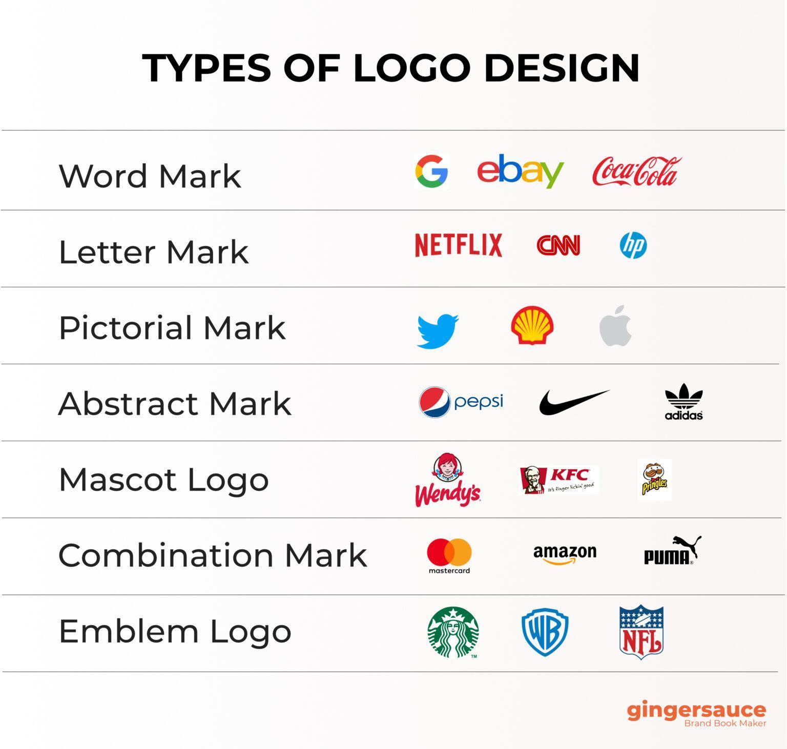
- Preferred Logo Style?
E.g Clean, modern, nature-inspired, playful
- Any crucial extra details to include?

